CUSTOMIZE WHAT YOU CAN SEE ON CIRCULATION SCREEN

- Log into circulation
- Pull up a patron record
- Right click and choose DESIGN MODE
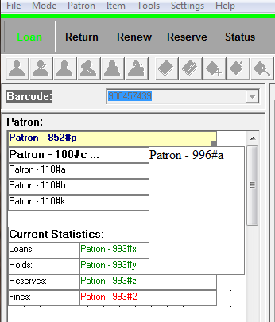
- Double click where it says “Patron-110#a” and then click on the Patron-110#a in the CONTENTS box and click REMOVE ITEM.
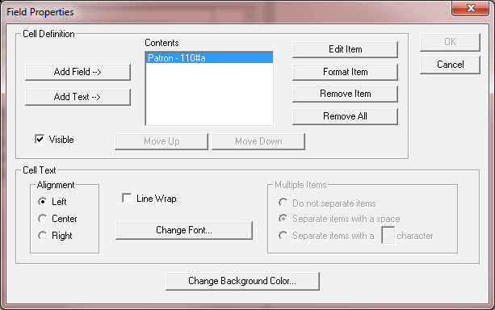
- Click on “Add Field” and choose “PATRON” table and then scroll down to find the 852#b- HOMEROOM field. Select that and hit OK. 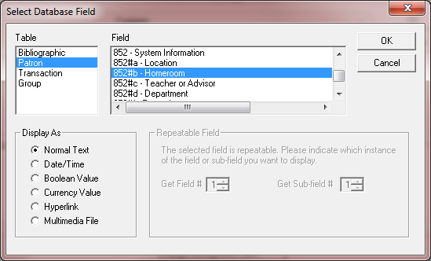
- Hit OK on the next screen.
- Back on the main screen, double click on the 110#b field and REMOVE ALL. Then do the same steps as above, but add the 852#g- Grade field.
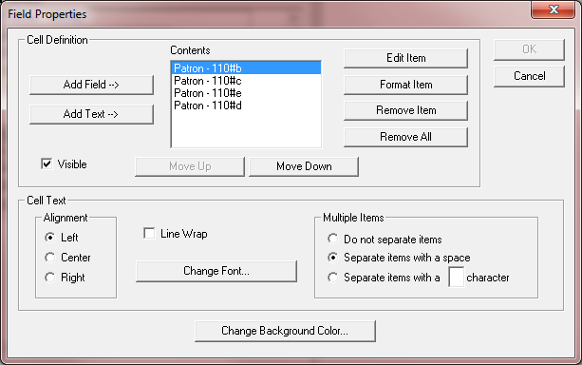
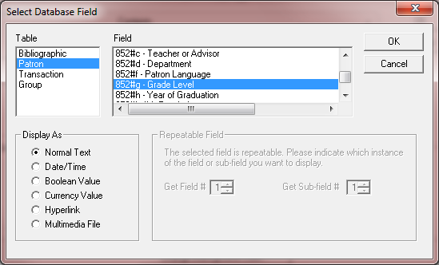
- Lastly, on the MAIN screen, click on the “Patron-110#k” box and REMOVE, UNCHECK the “Visible” box and then hit OK.
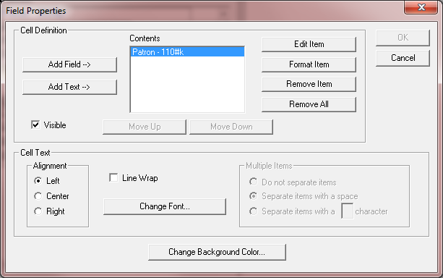
- Once you are back on the main screen, right click and EXIT DESIGN MODE. It’ll ask if you want to save changes and click YES. Your screen will now have only the information you want to see:
